Renju lesson on March 7, 2002

Hello everyone! Welcome to Online Renju Class. We now have our own Virtual Classroom. I want to say big thanks to luwenzhe who created this room in short time. He spent lots of time to do it! We are so thankful to him! We have one more person among us who is to be thanked as much! It is farmer, who have helped us a lot by hosting our website www.renjuclass.com. And today he used his fast new server to host our website. Now our website is with excellent speed performance. Big big thanks to farmer!
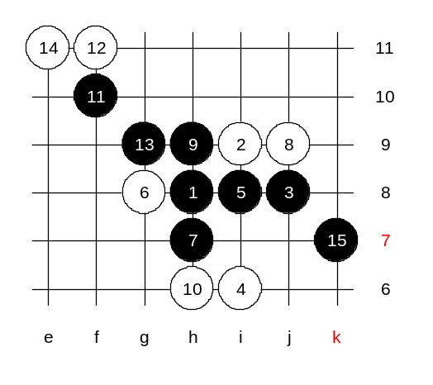
I must tell you that without the help of farmer and luwenzhe our class would never reach that far! It is not just nice words but very truth! We will now focus on the lesson itself. As we finished d13 last week, we will use new opening today. Since we forgot to vote for the new opening last week, I chose the opening that got second number of votes in our last voting. It is i3 opening. i3 used to be my favorite opening long ago. I was so eager about it and had lots of faith in it. I played it against almost anyone. It was about 10 years ago. I have a big research about i3 opening. I have the complete analysis of i3 for my new book, too. That will be the basis of our lessons. Short evaluation: i3 is very close to black win. Lets say, 95%. A master should get 100% from i3, of course. In my book, I have analysed 9 different 4th moves. Beginning form weakest, ending with strongest. Yes, those 4th moves include practically every place that has any influence. During analysis I found some critical differences regarding board edge distance. Some of the differences most of you never even suspect of. Lets begin with example of it. How much do you know about 4-i6? 90% of you will lose here as black. Although its black win. You just do not know where it is. We will not study the 5-i7 that is too easy black win. The other 5th move raised lots of questions before. Move 5-i8 is quite popular. By the 8th move it leads to the famous pattern of i4 opening. Some of you might know black win here. Move 11 - the key move. Move 12-f11 is the strongest. Any other 12th move loses fast. I feel relieved to teach i3 now, compared with d13, because here I know more about the opening. Yes, beautiful 15-k7 wins the game! It is famous theory, in fact.

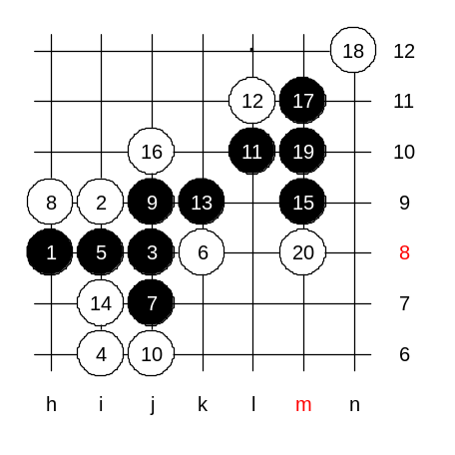
We switch 6th move, and unexpectedly there is a big difference. Now, suddenly, right side is narrow and no win!
This result actually brought me lots of headache before. While writing the book I needed to prove black win, but how?
No win here, agree? If one more line on right side then easy win. Here where the distance matters.

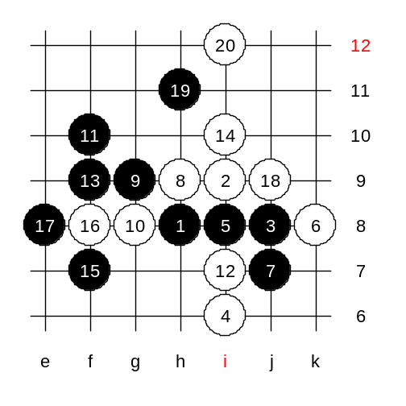
What are the other ways for black?

Move 9-g9 is strong, but not easy. Black must consider possible counter-attacks.
In this example, black loses.

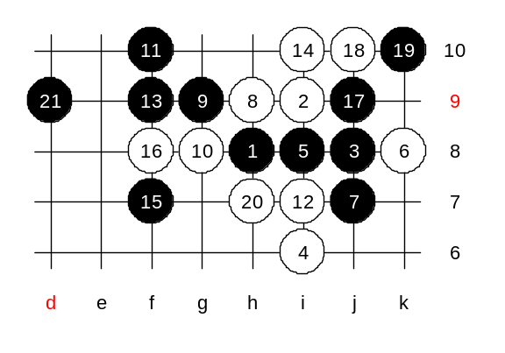
Here is the correct win.

I will introduce you one more method I found. 7-h9 should be win, too. It is easier because here white’s has no chance for counter-attack. 8-j7 is forced. 10-g8 is forced, too. Moves 11 and 13 are logical. Move 15-f10 gives black win. I analysed all possible blocks here. which move you want to try out?

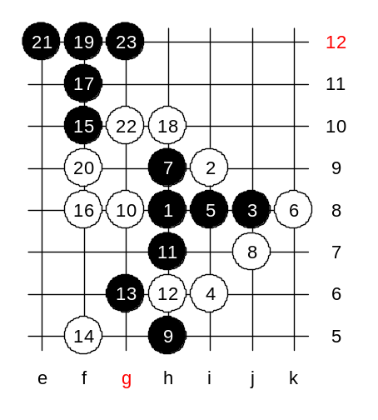
Here is the example:

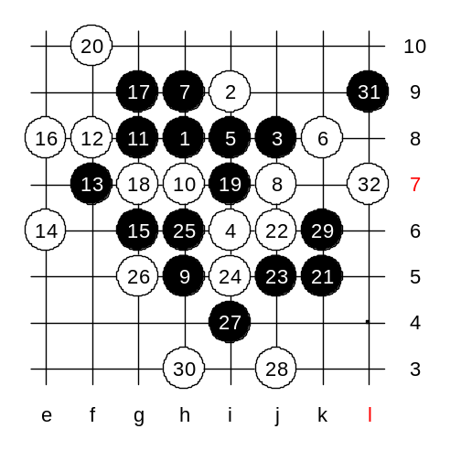
We changed 10th move. Here the black wins, too. Who wants to show? Ok, ASV777 shows.
If 16th to other side the 17-g10.
Well, seems the win is not simple. Lets end it here. And the truth will come out with homework.
ok, in the meantime, since time is late, we make the official ending to lesson. Then those who are in hurry may leave.

The following students are awarded today's participation credit point: span,jereman,luwenzhe,Rehnstedt,tunnet99,coco_yuang,hobbang,yyfcsd,guminzhao,wsbza,ASV777,Ikon,shadewawa,concord2497,civsnail,Oster666,farmer_,claire, F_Westberg.

